**Meeting Room Booking System Documentation**

-Table of Contents

-Introduction

-Project Overview

-Project Structure

-Features

-ER Diagrams

-Future Enhancements

-Conclusion

**1. Introduction**

The Meeting Room Booking System is a software application designed to manage meeting rooms, meetings, user accounts, and booking information. It provides a platform for users to efficiently book meeting rooms, schedule meetings, and maintain booking records.

**2. Project Overview**

The Meeting Room Booking System consists of several key components:

User Management: Users can register, log in, and be assigned roles (Admin, Manager, Member) based on their access level.

Meeting Room Management: Admins can add, update, and delete meeting rooms. Each room has attributes such as room name, seating capacity, amenities, and cost per hour.

Meeting Management: Users with Manager or Admin roles can schedule and manage meetings. Meetings include details like title, date, time, type, and participants.

Booking Information: Users can book meeting rooms for specific dates and times. Booking information includes room ID, booking date, start and end times, and the user who made the booking.

**3. Project Structure**

The project is structured into multiple layers:

Data Access Layer: Manages interactions with the database, including CRUD operations for users, meeting rooms, meetings, and booking information.

Service Layer: Implements business logic and rules. It coordinates data access and performs validations.

View Layer (Console UI): Provides a command-line interface for users to interact with the system. Users can perform actions like user management, meeting room management, meeting scheduling, and booking information management.

**4. Features**

User registration and authentication.

Role-based access control (Admin, Manager, Member).

Admins can manage users, meeting rooms, meetings, and booking information.

Managers can schedule and manage meetings.

Members can view available meeting rooms and booking information.

Booking meeting rooms for specific dates and times.

Comprehensive management of meeting rooms, meetings, and booking information.

**5. ER Diagrams**

Placeholders for ER diagrams (Entity-Relationship diagrams) can be inserted here. These diagrams will illustrate the relationships between different entities in the database, such as Users, Meeting Rooms, Meetings, and Booking Information.

**ER Diagram:**

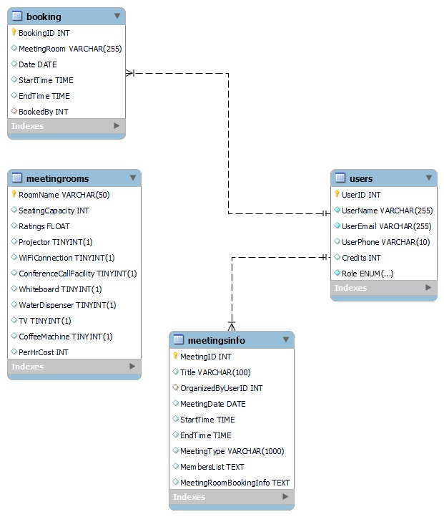

**6. Future Enhancements**

In future iterations, the Meeting Room Booking System can be extended with additional features such as:

Notifications and reminders for upcoming meetings.

Integration with calendar applications (e.g., Google Calendar).

Reporting and analytics for room utilization and meeting statistics.

Mobile and web interfaces for user convenience.

**7. The Application**

The Meeting Room Booking System is a project by the team G.O.A.T. The frontend was made using HTML , CSS and Javascript with usage of bootstrap classes. The Backend was made using java with a proper MVC structure and DAO implementations and can be accessed using the ConsoleUI class in the view package. The database used was MySQL table.

**7. Conclusion**

The Meeting Room Booking System is a versatile tool that streamlines the process of managing meetings and meeting rooms. With user-friendly interfaces and robust functionality, it enhances the efficiency of scheduling, booking, and resource management within an organization.